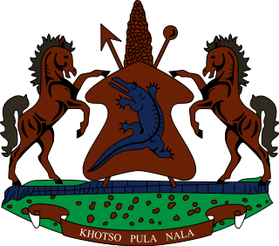
STATEMENT BY LESOTHO DELEGATION DURING THE THIRTY FIFTH SESSION OF THE UNIVERSAL PERIODIC REVIEW WORKING GROUP ON LIBERIA
2 NOVEMBER 2020
Thank you, Madam. President,
Lesotho welcomes the delegation of Liberia to the Working Group and we congratulate them for the presentation of their National Report. We commend Liberia for developing strategies and programmes geared towards improving socio-economic conditions, strengthening the rule of law and ensuring access to justice.
My delegation wishes to make the following recommendations for consideration by the delegation of Liberia: 1. To strengthen measures to safeguard the rights of women and girls, particularly in the areas of maternal, sexual and reproductive health, and healthcare for people living with HIV/AIDS. 2. To continue efforts to eliminate FGM across the country.
Finally, we wish Liberia every success with this UPR cycle.

