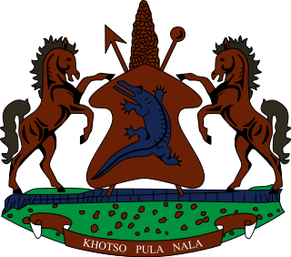
STATEMENT BY LESOTHO DELEGATION DURING THE THIRTY SIXTH SESSION OF THE UNIVERSAL PERIODIC REVIEW WORKING GROUP ON LIBYA
11 NOVEMBER 2020
Thank you, Madam. President,
Lesotho welcomes the delegation of Libya to the Working Group. We wish to appreciate the efforts made by Libya to safeguard the human rights of its people in various sectors in the country. We comment Libya for promoting the right to health of its people by providing free health-care services in various health facilities in the country.
Notwithstanding the positive developments, we wish to make the following recommendations for consideration by the delegation of Libya. 1. To strengthen efforts to bring to book perpetrators of violations of human rights, more particularly those infringing the right to life. Secondly, to ratify the Convention for the Protection of All Persons from Enforced Disappearance.
Finally, we wish Libya every success with this UPR cycle.

