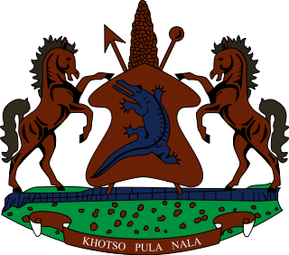
STATEMENT BY LESOTHO DELEGATION DURING THE THIRTY SIXTH SESSION OF THE UNIVERSAL PERIODIC REVIEW WORKING GROUP ON MARSHALL ISLANDS
9 NOVEMBER 2020
Thank you, Madam. President,
Lesotho welcomes the delegation of Marshal Islands to the Working Group. We take note of the steps which Marshal Islands has taken in various areas to promote and protect human rights of its people. We applaud Marshal Islands for their appointment as a member in the Human Rights Council for 2020-2021. Further, we comment them for enacting the 2017 Prohibition of Trafficking in Persons Act, aimed at preventing and combating trafficking in persons.
We wish to make the following recommendations for consideration by Marshal Islands: to consider ratifying the Convention on the Protection of the Rights of Migrant Workers and Members of their Families, as well the ratifying the Convention for the Protection of All Persons from Enforced Disappearances.
Finally, we wish Marshall Islands every success with this UPR cycle.

