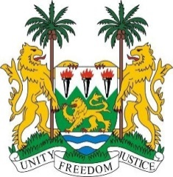
PERMANENT MISSION OF SIERRA LEONE TO
THE UNITED NATIONS IN GENEVA

36th Session of the Universal Periodic Review
(2nd – 13th NOVEMBER, 2020)

LIBYA

11th November 2020

Madam President,

Sierra Leone warmly welcomes the Libyan delegation and thanks them for the presentation of their 3rd cycle national UPR report

My delegation notes with satisfaction the launch this week of the Libyan Political Dialogue forum in cooperation with the United Nations in Tunis, which is an opportunity for peace and national reconciliation for all Libyans.

Sierra Leone is concerned about the reports of enslavement, cruelty and violations perpetrated by groups in Libya against African migrants transiting Libya.

In the spirit of constructive dialogue, Sierra Leone makes the following recommendations:

- Call on all parties in Libya to renew their commitment to the Libyan Political Dialogue Forum in cooperation with the UN.

- Continue to reform Libyan detention facilities to ensure humane treatment of migrants and other detainees.

- Guarantee greater participation of women and minorities in Libya’s political and economic life, including promoting greater representation in Parliament.

- End all discrimination against women, as well as child and forced marriages.

To conclude, Sierra Leone wishes Libya a successful 3rd cycle review.

Thank you, Madam President.

