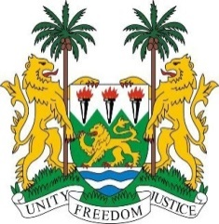

PERMANENT MISSION OF SIERRA LEONE TO
THE UNITED NATIONS IN GENEVA

36th Session of the Universal Periodic Review

MALAWI

3rd November 2020

Mister Vice President,

Sierra Leone warmly welcomes the delegation of the sister Republic of Malawi and thanks them for the presentation of their national report.

Sierra Leone notes with satisfaction that despite Malawi's last electoral challenges, the country has displayed admirable democratic values and the rule of law to conduct a transparent and peaceful political transition in June 2020. In this regard, we congratulate the judges of the constitutional court of Malawi for the award received from Her Majesty Queen Elizabeth II and other global institutions. We also congratulate Malawi for electing its first female Speaker of Parliament.

Sierra Leone commends the Government of Malawi for establishing a Human Rights Section in the Ministry of Justice and Constitutional Affairs, the Independent Complaints Commission for Police and the National Children's Commission. These and other measures taken by the Government of Malawi will widen civic space, protect children's rights, and guarantee accountability in public institutions.

In the spirit of constructive engagement, my delegation makes the following recommendations for due consideration by Malawi:

- Provide adequate training and support to law enforcement agencies to investigate attacks and killings of vulnerable groups, including persons with albinism and human rights defenders.

- Implement the 2017 Access to Information Act, the 2012 Disability Act, and other progressive laws and policies that have yet to be implemented.

- Address early childhood and forced marriages.

- Establish a de jure moratorium on the death penalty.

Sierra Leone wishes Malawi every success in its 3rd Review Cycle.

I thank you.

