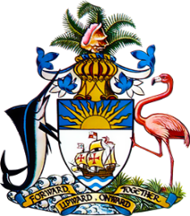

Statement by Ms. Sasha Dixon, Second Secretary
Permanent Mission of The Bahamas to the United Nations Office and Other International Organizations in Geneva
at the 36thSession of the Universal Periodic Review Working Group
Presentation of National Report by the Government of Jamaica
Wednesday, 11 November, 2020

Thank you, Madam/Mr.[Vice] President.
The Bahamas extends a warm welcome to the sister Caribbean Community (CARICOM) delegation of Jamaica, thanks the country for its report and commends the engagement in this UPR process.
In a constructive spirit, The Bahamas recommends that Jamaica:

- Ensures adequate resources are provided for implementation of its National Poverty Reduction Plan so as to sustain momentum and advance the Plan’s multi-faceted approach;
- Continues efforts to have all child diversion facilities fully operational in each parish by the end of November 2020, in keeping with the set goal;
and
- Strengthens the legislative, policy and advocacy environment to address discrimination in access to HIV/AIDS treatment.

We commend Jamaica for its progress in the field of human rights over the reporting period, including a number of initiatives to promote gender equality and eliminate gender-based violence as well as to promote and protect children’s rights. Ongoing efforts to strengthen the national Climate Change Policy Framework are also most welcome.

As a fellow Small Island Developing State (SIDS), we recognise the challenges faced by Jamaica, including due to limited resources and the disproportionate threats posed by climate change. We therefore encourage Jamaica to avail itself of technical assistance and capacity-building support, in accordance with its human rights priorities and call on the international community to cooperate with the country in this regard.

We wish Jamaica every success in this UPR process.

I thank you.

