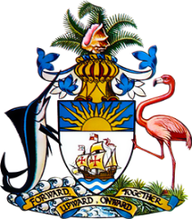

Statement by Ms. Sasha Dixon, Second Secretary
Permanent Mission of The Bahamas to the United Nations Office and Other International Organizations in Geneva
at the 36th Session of the Universal Periodic Review Working Group
Review of The Republic of Croatia
10th November, 2020
Thank you [Mr/Madame] [Vice] President.
The Bahamas extends a warm welcome to the delegation of The Republic of Croatia and commends the country’s commitment to this UPR process.
In a constructive spirit, The Bahamas recommends that Croatia:
- Intensifies efforts to prevent and address discrimination against women, particularly in education and employment, by putting in place adequate safeguards to ensure the full realization of women’s rights;
- Strengthens national efforts to combat racism and discrimination against minorities and other groups in vulnerable situations, such as refugees and asylum seekers
and
- Establishes measures to ensure individuals with disabilities have access to quality social and community support, with an emphasis on healthcare, education and employment.
We applaud Croatia’s progress in the field of human rights and note Croatia’s ratification of the Istanbul Convention as well as adoption of a national strategy for protection against domestic violence. Moreover, the State’s announcement of proposed amendments to the Criminal Code to ensure stronger penalties for domestic violence, sexual violence and violence against women is welcomed and we encourage Croatia to continue such efforts.
We wish Croatia every success in this UPR process.

I thank you.

