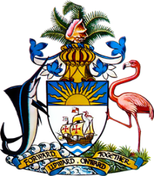

Statement by Ms. Sasha Dixon
Permanent Mission of The Bahamas to the United Nations Office and Other International Organizations in Geneva
at the 36th Session of the Universal Periodic Review Working Group
Presentation of National Report by the Government of
the United States of America
9 November, 2020

Thank you, Madam/Mr. [Vice] President.
The Bahamas extends a warm welcome to the delegation of the United States of America, thanks the country for its national report and commends the country’s emgagement in this UPR process.
We congratulate the United States on efforts to combat trafficking in persons, to promote access to health care, and to address domestic violence through the development of various programmatic and policy initiatives.

Moreover, we recognise efforts to promote human rights education and equality of educational opportunity.

In a constructive spirit, The Bahamas recommends that the United States:

- Ratifies the Convention on the Elimination of All Forms of Discrimination against Women (CEDAW)

- Ratifies the Convention on the Rights of the Child (CRC)

and;

- Advances toward the implementation of instruments to combat climate change and its negative impacts on human rights

We wish the United States every success in this UPR process.

I thank you.

