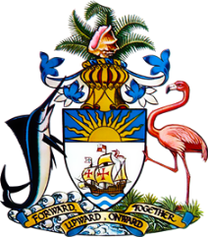

Statement by Ms. Sasha Dixon,
Permanent Mission of The Bahamas to the United Nations Office and Other International Organizations in Geneva
at the 36th Session of the Universal Periodic Review Working Group
Presentation of National Report by the Government of the
Republic of the Marshall Islands
9th November, 2020

Thank you, Madam/Mr. [Vice] President.
The Bahamas extends a warm welcome to the delegation of the Republic of the Marshall Islands and thanks the country for its national report.
In a constructive sprit, The Bahamas recommends that the Marshall Islands:

- Signs and ratifies the 1951 Convention relating to the Status of Refugees and its 1967 Protocol;
- commences a widespread public awareness campaign on human trafficking and
- increases efforts to investigate and prosecute traffickers;
We commend the commitment of The Marshall Islands to promoting and protecting human rights, including through the passage or amendment of eleven (11) pieces of legislation and accession to four (4) human rights treaties and three (3) Optional Protocols, during the reporting period.

Moreover, we positively recognise the country for its leadership in championing the need to address climate change and its impacts on human rights, including as a fellow Small Island Developing State (SIDS) Member of the Human Rights Council. Being, also an archipelagic nation like the Marshall Islands, The Bahamas understands the challenges faced, including limited human resources and the need to duplicate services throughout the islands. We therefore encourage the Marshall Islands to avail itself of technical assistance and capacity-building support, in accordance with its human rights priorities, and call on the international community to cooperate with the country in this regard.

We wish the Marshall Islands every success in this UPR process.

I thank you.

