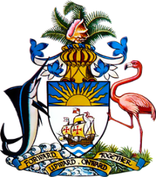

Statement by Ms. Sasha Dixon, Second Secretary
Permanent Mission of The Bahamas to the United Nations Office and Other International Organizations in Geneva
at the 36th Session of the Universal Periodic Review Working Group
Presentation of National Report by the Government of the Republic of Bulgaria
6th November, 2020

Thank you, Madam/Mr. [Vice] President.
The Bahamas extends a warm welcome to the delegation of Bulgaria and thanks the country for its national report.
In a constructive spirit, The Bahamas recommends that Bulgaria:

- develops Standard Operating Procedures for asylum seekers and refugees to assist with correctly identifying asylum-seekers in particularly vulnerable situations and provide them with safe accommodation and adequate support;
- commences a widespread educational campaign on domestic violence; and
- increases funding to provide shelter and support for victims of domestic violence

We welcome the commitment of Bulgaria to promote and protect the human rights of all persons residing in its territory. In particular, we congratulate Bulgaria’s National Ombudsman for obtaining “A” status accreditation, in compliance with the Paris Principles.

We further commend Bulgaria for its legislative amendments to the Criminal Code that were adopted to regulate the protection of the rights of victims of violence, including domestic violence, and we recognise the progress made by Bulgaria in implementing various international human rights instruments during the reporting period.
In closing, we wish Bulgaria every success in this UPR process.

I thank you.

