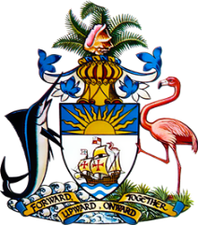

Statement by Ms. Sasha Dixon, Second Secretary
Permanent Mission of The Bahamas to the United Nations Office and Other International Organizations in Geneva
at the 36th Session of the Universal Periodic Review Working Group
Presentation of National Report by the Government of Honduras
5th November, 2020

Thank you, Madam/Mr. [Vice] President.
The Bahamas extends a warm welcome to the delegation of Honduras and thanks the country for its report.
In a constructive spirit, The Bahamas recommends that Honduras:

- moves forward with bringing into force the regulations to accompany the Trafficking Act;

- continues efforts to execute its response plans for displacement;

- continues efforts to improve access to justice;
- establishes a Ministry or Department with a specific mandate to address issues relating to climate change

We commend Honduras for implementing various treaties, laws, regulations and public policy measures in an effort to promote and protect human rights. We particularly highlight the establishment of the Ministry of Human Rights, with a mandate to advise the government and other relevant institutions on their compliance with national and international human rights commitments and to coordinate related activities.

We also commend Honduras for its efforts in increasing access to child registration by opening five new branches of the National Registry Office and setting up help desks at various hospitals.

In closing, we wish Honduras every success in this UPR process.

I thank you.

