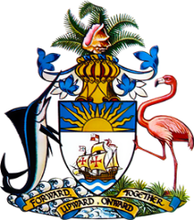

Statement by Ms. Sasha Dixon, Second Secretary
Permanent Mission of The Bahamas to the United Nations Office and Other International Organizations in Geneva
at the 36th Session of the Universal Periodic Review Working Group
Presentation of National Report by the Government of Maldives
Wednesday, 4 November, 2020

Thank you, Madam/Mr. [Vice] President.
The Bahamas extends a warm welcome to the delegation of the Maldives, thanks the country for its report and commends its engagement in this UPR process.
In a constructive spirit, The Bahamas recommends that the Maldives:

- Accelerates efforts toward the establishment of a National Mechanism for Implementation, Reporting and Follow-up (NMIRF) as a standing government structure mandated to coordinate reports as well as follow-up and implementation of recommendations made by international human rights bodies and mechanisms;
- Develops targeted, evidence-based policies, including the promotion of public awareness, towards ending female genital mutilation in the Maldives;
and
- Seeks technical and capacity-building assistance to complement State efforts in training relevant personnel to identify, investigate and prosecute cases of human trafficking

As a fellow archipelagic Small Island Developing State (SIDS), we recognise the challenges faced by the Maldives, including limited human resources, the need to duplicate services throughout its islands and the threats posed by climate change. We encourage the Maldives to avail itself of technical assistance and capacity-building support, in accordance with its human rights priorities, and call on the international community to cooperate with the country in this regard.

We wish the Maldives every success in this UPR process.

I thank you.

