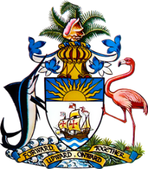

Statement by Ms. Sasha Dixon, Second Secretary
Permanent Mission of The Bahamas to the United Nations Office and Other International Organizations in Geneva
at the 36th Session of the Universal Periodic Review Working Group
Presentation of National Report by the Government of Mongolia
Wednesday, 4 November, 2020

Thank you, Madam/Mr. [Vice] President.
The Bahamas extends a warm welcome to the delegation of Mongolia, thanks the country for its report and commends the country’s commitment to this UPR process.
In a constructive spirit, The Bahamas recommends that Mongolia:

- Establishes a National Mechanism for Implementation, Reporting and Follow-up (NMIRF) as a standing government structure mandated to coordinate reports as well as follow-up and implementation of recommendations made by international human rights bodies and mechanisms;
- Strengthens efforts to prevent and eradicate human trafficking, including by accelerating considerations to amend Article 8.1 of the criminal procedural code so that access to protective services for victims is not obstructed by the need for prosecutors to initiate cases against the alleged traffickers;
and
- Expands access to shelters and victim support services for victims of domestic violence with disabilities and ensures adequate training, for relevant personnel, on their specific needs and vulnerabilities.

We welcome Mongolia’s progress in the field of human rights, including efforts aimed at decreasing air pollutants and prohibiting the use of unprocessed coal in accordance with the 2017 Mongolia national program on reduction of air and environmental pollution. We encourage Mongolia to continue efforts toward introducing cleaner energy sources and technologies.

In closing, we wish Mongolia every success in this UPR process.

I thank you.

