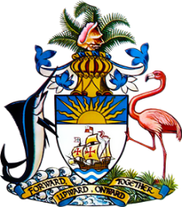

Statement by Ms. Sasha Dixon, Second Secretary
Permanent Mission of The Bahamas to the United Nations Office and Other International Organizations in Geneva
at the 36th Session of the Universal Periodic Review Working Group
Presentation of National Report by the Government of Panama
Tuesday, 3 November, 2020

Thank you, Madam/Mr. [Vice] President.
The Bahamas extends a warm welcome to the delegation of Panama and commends the country for its report and commitment to this UPR process.
In a constructive spirit, The Bahamas recommends that Panama:

- Intr oduce into legislation a definition of human trafficking that is in line with the UN Protocol to Prevent, Suppress and Punish Trafficking in Persons;
- Undertake efforts to increase coverage of quality educational services at all levels, including for indigenous and Afropanamanian children and with an emphasis on working toward the provision of universal preschool education;
and
- Strengthen implementation of Executive Decree No. 53 of 2002, including through increased public awareness, to ensure that, in practice, employers do not discriminate against women by reason of pregnancy or the intention to become pregnant.

We welcome Panama’s progress in the field of human rights, including improvements achieved in women’s political participation and encourage the country to continue efforts in this area, particularly for women vulnerable to multiple and intersecting forms of discrimination such as women with disabilities, indigenous and Afrodescendant women.
We also commend Panama for efforts in the area of human rights and the environment including its intention to host the 2021 Our Ocean Conference.

In closing, we wish Panama every success in this UPR process.

I thank you.

