Mission Permanente  du Royaume du Maroc  Genève | 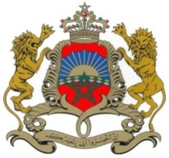

36ème Session de l’Examen Périodique Universel
Déclaration du Royaume du Maroc
Examen des Etats Unis
09 novembre 2020

Madame President,

Morocco welcomes The United States of America’s participation in the UPR and notes the positive steps taken since its last review.
Morocco welcomes the ratification by the American Government of the Convention on the Prevention and punishment of the crime of genocide, ant the protocol relating to the Status of Refugees.
My delegation welcomes the introduction by the United States of its Strategy on Women, Peace and Security in June 2019.
Morocco expresses its support to the migrant and seasonal agricultural worker protection policy aiming at the protection of the rights of seasonal workers.
Finally, Morocco would like to recommend the ratification of the Convention on the Elimination of all Forms of Discrimination against women and the Convention on the Rights of the Child.
Thank you Madam President.

