Mission Permanente  du Royaume du Maroc  Genève | 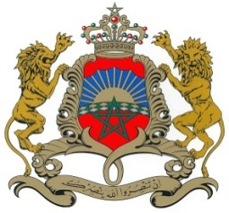

36ème Session de l’Examen Périodique Universel
Examen des Maldives
Déclaration du Royaume du Maroc
Genève, le 4 novembre 2020

Madame President,
Morocco welcomes The Maldives’ participation in the UPR and notes the positive steps taken since its last review.
Morocco welcomes The National Human Rights Framework launched in 2016 which identifies 14 outcome areas for the promotion, protection and fulfillment of fundamental rights
My Delegation welcomes the signature by the President of the declaration in relation to Article 22 of CAT, recognizing the competence of the Committee against Torture to receive and consider individual communications.
Morocco expresses its support to the large-scale social housing project across the country with 20000 social housing units across the country, as well as the renewed Health Master Plan (2016–2025).
Morocco would like to recommend the ratification of 2 important instruments: the International Convention on the Protection of the Rights of All Migrant Workers and Members of Their Families and the International Convention for the Protection of All Persons from Enforced Disappearance.
Thank you Madam President.

