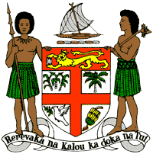
PERMANENT MISSION OF THE REPUBLIC OF FIJI TO THE UNITED NATIONS
OFFICE AND OTHER INTERNATIONAL ORGANISATIONS AT GENEVA
36TH SESSION OF THE UPR WORKING GROUP
[PANAMA]

Fiji welcomes the delegation of Panama and congratulates it for the achievements in the implementation of the recommendations from its previous cycle.
Fiji commends Panama’s efforts to adapt their environmental laws to address new environmental challenges and the efforts in developing an institutional framework with a view to updating policies on climate change, biodiversity and water resource management.
Fiji offers the following recommendations:
- Continue to intensify efforts to develop and strengthen the necessary legislative frameworks that address cross-sectoral environmental challenges, including climate change and disaster risk reduction frameworks;
- Continue to ensure the full participation of young people in decision-making processes, including in the design and implementation of programmes, policies, and strategies that improve their leadership and their contribution to peace, stability, security and sustainable development; and
- Take measures to ensure that comprehensive and age-appropriate education on sexuality and reproductive health and rights is systematically integrated into school curricula.
We wish the delegation every success in its review.
I thank you.

