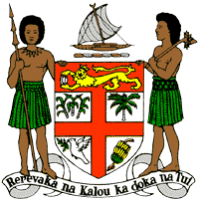
PERMANENT MISSION OF THE REPUBLIC OF FIJI TO THE UNITED NATIONS
OFFICE AND OTHER INTERNATIONAL ORGANISATIONS AT GENEVA
36TH SESSION OF THE UPR WORKING GROUP
[MONGOLIA]

Fiji welcomes the delegation of Mongolia and congratulates it on its participative and consultative process undertaken in the implementation of the recommendations from its previous cycle.
Fiji commends Mongolia for the abolishment of the death penalty, the efforts to combat trafficking in persons through the National Program on “Combatting the Crime of Trafficking in Persons”, and the various legislative reforms undertaken such as the adoption of the Law on Child Rights, the Law on Child Protection and the Law on Rights of People with Disabilities.
Fiji offers the following recommendations:
- Intensify efforts to develop and strengthen the necessary legislative frameworks that address cross-sectoral environmental challenges, including climate change and disaster
risk reduction frameworks;
- Enhance support services for victims of domestic and gender-based violence, and take measures to raise awareness among law enforcement officials, lawyers and judges of the specific needs and vulnerabilities of women and girls who are victims of domestic and gender-based violence; and
- Integrate age-appropriate education on sexual and reproductive health and rights into school curricula.
We wish the delegation every success in its review.
I thank you.

