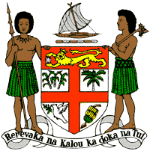
PERMANENT MISSION OF THE REPUBLIC OF FIJI TO THE UNITED NATIONS
OFFICE AND OTHER INTERNATIONAL ORGANISATIONS AT GENEVA
36TH SESSION OF THE UPR WORKING GROUP
[MALDIVES]

Fiji welcomes the delegation of the Republic of Maldives and congratulates the delegation for the achievements in the implementation of the recommendations from its previous cycle.
Fiji commends Maldives on the advancements of its legal frameworks on the protection of children, and its commitment to ensuring gender equality and effective protection of women.
Fiji offers the following recommendations:
- Ensure that women, especially rural women, children, persons with disabilities and indigenous and local communities are meaningfully engaged in the development and implementation of climate change and disaster risk reduction frameworks;
- Strengthen efforts to ensure the effective investigation, prosecution and punishment for all acts of torture and ill-treatment, and provide access to justice and rehabilitation to victims of torture;
- Strengthen efforts in law and in practice to explicitly prohibit all forms of female genital mutilation; and
- Consider abolishing the death penalty;
We wish the delegation every success in its review.
I thank you.

