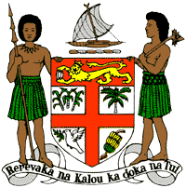
PERMANENT MISSION OF THE REPUBLIC OF FIJI TO THE UNITED NATIONS
OFFICE AND OTHER INTERNATIONAL ORGANISATIONS AT GENEVA
36TH SESSION OF THE UPR WORKING GROUP
[MALAWI]

Fiji welcomes the delegation of Malawi and congratulates it for the achievements in the implementation of the recommendations from its previous cycle. In particular, Fiji commends Malawi for the various legislative amendments to further the promotion and protection of human rights, and the adoption of policy frameworks and human rights related action plans such as the National Action Plan on Child Labour Elimination and the National Plan of Action against Trafficking in Persons.
Fiji offers the following recommendations:
- Intensify efforts to develop and strengthen the necessary legislative frameworks that address cross-sectoral environmental challenges, including climate change and disaster risk reduction frameworks;
- Consider abolishing the death penalty;
- Improve access to adequate sexual and reproductive health services, in particular to antenatal, delivery and postnatal services.
- Implement the commitment made by the Government at the Nairobi Summit on ICPD25 to provide 12 years of quality free education for every child, ensuring that girls and boys enjoy a full primary and secondary education and equal access to vocational, technical and higher education courses.
We wish the delegation every success in its review.
I thank you.

