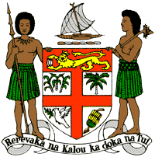
PERMANENT MISSION OF THE REPUBLIC OF FIJI TO THE UNITED NATIONS
OFFICE AND OTHER INTERNATIONAL ORGANISATIONS AT GENEVA
36TH SESSION OF THE UPR WORKING GROUP
[HONDURAS]

Fiji welcomes the delegation of Honduras and congratulates the delegation for the achievements in the implementation of the recommendations from its previous cycle.
Fiji commends Honduras for the establishment of its Ministry of Human Rights, which has, amongst other things, overseen the preparation and timely submission of all treaty body reports, and has held nine dialogues with treaty bodies. Fiji also commends Honduras for the various legislative reforms undertaken since its last review, with the aim of upholding, protecting and promoting human rights.
Fiji offers the following recommendations:
- Intensify efforts to develop and strengthen the necessary legislative frameworks that address cross-sectoral environmental challenges, including climate change adaptation and mitigation frameworks;
- Ensure that women, children, persons with disabilities, and indigenous and local communities are meaningfully engaged in the development and implementation of climate change and disaster risk reduction policies;
- Strengthen efforts to ensure that persons with disabilities have access to health, education and social services and ensure their full integration in society; and
- Strengthen efforts to address violence against women and children, including measures to prevent violence and support survivors, and by removing obstacles that prevent access to justice.
We wish the delegation every success in its review.
I thank you.

