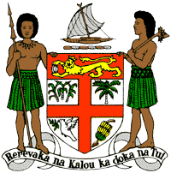
PERMANENT MISSION OF THE REPUBLIC OF FIJI TO THE UNITED NATIONS
OFFICE AND OTHER INTERNATIONAL ORGANISATIONS AT GENEVA
36TH SESSION OF THE UPR WORKING GROUP
[BULGARIA]

Fiji welcomes the delegation of Bulgaria and congratulates the delegation for the achievements in the implementation of the recommendations from its previous cycle, including the submission of a mid-term report.
Fiji commends Bulgaria for enhancing its legislative framework to better protect the rights of victims of violence, as well as the adoption of the National Action Plan for the Promotion of Equality between Women and Men.
Fiji offers the following recommendations:
- Intensify efforts to develop and strengthen the necessary legislative frameworks that address cross-sectoral environmental challenges, including climate change adaptation and mitigation frameworks;
- Ensure that women, children, persons with disabilities, and indigenous and local communities are meaningfully engaged in the development and implementation of climate change and disaster risk reduction policies;
- Strengthen efforts to eliminate discrimination and violence based on sexual orientation and gender identity, actual or perceived, in compliance with its human rights obligations; and
- Strengthen efforts to ensure the effective implementation of the National Anti-trafficking Strategy, and ensure that the National Commission for Combating Trafficking in Human Beings is provided with sufficient funds to carry out its functions.
We wish the delegation every success in its review.
I thank you.

