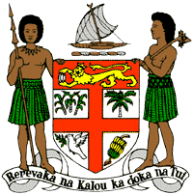
PERMANENT MISSION OF THE REPUBLIC OF FIJI TO THE UNITED NATIONS
OFFICE AND OTHER INTERNATIONAL ORGANISATIONS AT GENEVA
36TH SESSION OF THE UPR WORKING GROUP
[ANDORRA]

Fiji welcomes the delegation of Andorra and congratulates the delegation for the achievements in the implementation of the recommendations from its previous cycle.
Fiji commends Andorra for enhancing the enjoyment of sexual and reproductive health and rights for all, especially women, through the creation of the Sexual and Reproductive Health Service, as well as the various legislative labour reforms undertaken, including the measures taken to guarantee the right to work for the most vulnerable.
Fiji offers the following recommendations:
- Intensify efforts to develop and strengthen the necessary legislative frameworks that address cross-sectoral environmental challenges, including climate change adaptation and mitigation frameworks;
- Ensure that women, children, and persons with disabilities are meaningfully engaged in the development and implementation of climate change and disaster risk reduction policies; and
- Strengthen efforts to address violence against women and children, including measures to prevent violence and support survivors, and by removing obstacles that prevent access to justice.
We wish the delegation every success in its review.
I thank you.

