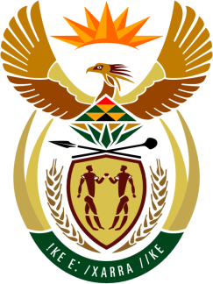

SOUTH AFRICAN PERMANENT MISSION
TO THE UNITED NATIONS
AND OTHER INTERNATIONAL ORGANISATIONS

UNIVERSAL PERIODIC REVIEW

Review of Marshall islands

9 November 2020

PALAIS DES NATIONS

(Via Zoom platform)

Check against delivery

President,

South Africa welcomes the Hon. Casten N. Nemra, Minister of Foreign Affairs and Trade of the Marshall Islands to this UPR Session.

In order to ensure progress in promoting and protecting human rights, we respectfully recommends that the Marshall Islands:

- Establish and fully operationalize a National Human Rights Commission in line with the Paris Principles;

- Expedite the establishment of processes to domesticate international human rights instruments ratified by the country;

- Urgently address patriarchal norms to affirm Womens rights;

- To further address relevant norms and standards to affirm children’s rights and to bring its juvenile justice system fully into line with the Convention on the Rights of the Child and other relevant standards as well as to strengthen both the quality and the availability of mental health-care services and programmes for children, and

- Strictly enforce its legislation on trafficking in persons by adopting a comprehensive national action plan and expedite the adoption of the standard operating procedures for law enforcement and the review of immigration policies;

President,

Having made the recommendations South Africa welcomes that the Marshall Islands (RMI), in keeping with its international commitments has recently ratified the International Covenant on Economic, Social and Cultural Rights (ICESCR); International Covenant on Civil and Political Rights (ICCPR); Convention against Torture and Other Cruel, Inhuman or Degrading Treatment or Punishment (CAT); Convention on the Elimination of All Forms of Racial Discrimination (CERD); two Optional Protocols to the CRC on the sale of children, child prostitution and child pornography, and on a communications procedure; and the Optional Protocol to the CEDAW establishing the individual complaints procedure.

South Africa wishes the Marshall Islands a successful review.

Thank you

