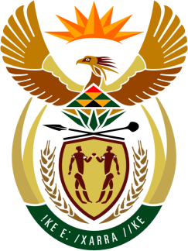

SOUTH AFRICAN PERMANENT MISSION
TO THE UNITED NATIONS
AND OTHER INTERNATIONAL ORGANISATIONS

UNIVERSAL PERIODIC REVIEW

9 NOVEMBER 2020

PALAIS DES NATIONS

Review oF UNITED STATES OF AMERICA

VIRTUAL (ZOOM PLATFORM)
(55 seconds)

Check against delivery

President,

South Africa welcomes the distinguished delegation of the United States of America to this UPR Session.

South Africa respectfully make the following recommendations:

- To cooperate fully with the High Commissioner in the preparation of her report on “systemic racism, violations of international human rights law against Africans and people of African descent by law enforcement agencies, as the HRC called upon all states to do, in resolution A/HRC/43/1.

- Adopt and promote a comprehensive national plan to combat, racism, racial discrimination, xenophobia and related intolerance, including incitement of hatred.

- Take further steps to reform the criminal justice system, which seeks to reform sentencing laws, such as the so-call “3 strikes rules”, that have wrongly and disproportionately harmed the African-American communities, with life imprisonment for non-violent crimes.

- South Africa further encourages the USA to ratify all Conventions and other instruments it had committed to in its previous Universal Periodic Reviews of 2010 and 2015, and have not done so yet (such as, inter alia, the Convention on all forms of discrimination against women)

President,

My delegation commends the USA on it’s efforts to begin to address the issues of racial profiling and excessive use of force by police, and establishing improved police community relations, through the signing of an executive order on “safe Policing for Safe Communities” in June 2020, as well as its efforts to reform the criminal justice system, by signing into law the “First Steps” which seeks to reform sentencing laws that have wrongly and disproportionately harmed the African-American communities.

South Africa wishes the United States of America a successful review.

I thank you.

