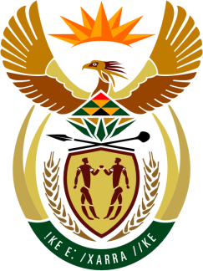

SOUTH AFRICAN PERMANENT MISSION
TO THE UNITED NATIONS
AND OTHER INTERNATIONAL ORGANISATIONS

36th SESSION OF THE WORKING GROUP ON THE
UNIVERSAL PERIODIC REVIEW

Review of JaMAiCA

11 November 2020

virtual (zoom platform)

Check against delivery

President,

South Africa welcomes the Hon. Minister Kamina Johnson Smith and the distinguished delegation of Jamaica to this UPR Session.

South Africa congratulates Jamaica on its 12th year of implementation of Vision 2030, which is evidence-driven; underpinned by principles of sustainability, equity, and inclusion; and integrates the economic, social, environmental and governance aspects of national development.

South Africa respectfully wishes to make the following recommendations:

- Continue the laudable efforts by the Government to boost economic growth and environmental sustainability, and reduce the rate of chronic non-communicable diseases (NCDs, and poverty levels, particularly rural and child poverty.

- Continue the efforts to meet its reporting obligations; in spite of human and resources constraints which can impede the timely submission of reports, and continue its consistent demonstration of its willingness to cooperate with the mechanisms of the UN human rights systems, including UN treaty bodies.

South Africa wishes Jamaica a successful review.

I thank you.

