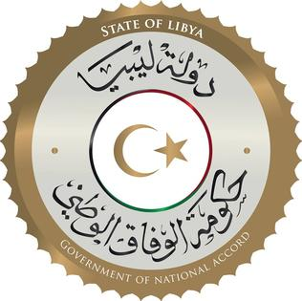
State of Libya
Opening Statement
Delivered by
H.E. Mr. Tamim M. Baiou
Ambassador / Permanent Representative
36th Universal Periodical Review
Human Rights Council
Wednesday November 11, 2020

Thank you, Mme. President,
Excellencies,
Members of the Troika,
Colleagues,
Ladies & Gentlemen,
Good morning.
It is an honor to be here today to present to you the Libya delegation that will review with you the 3rd Libya-Universal Periodical Review of 2019.
The Government of National Accord is committed to the Universal Review Process, as it sees it as a pivotal tool to help measure, advance, and protect Human Rights in Libya.
Much has happened in Libya since the last presented report, of May 13 of 2015. Regrettably, for the most part, what transpired were not events that were conducive to the furthering of promotion and protection of Human Rights. In fact, they were events that posed major challenges to the Government of National Accord.
To put things in perspective, and to give a time capsule, of sorts, for some of the major challenges that negatively impacted the stability of Libya during this period, and after the Skhirat Libyan political agreement, which was drawn in December 2015 and followed by the GNA assuming its duties in the capital, in March 2016, which was run by chaos before then,
Include;
- The Benghazi war escalated and became a deadly and destructive adventure.
- May 2016, the war on terror campaign was declared by the GNA in Sirte where ISIS was defeated, and the war ended in Dec. 2016.
- January 2017, meddling in by regional and international countries began to take a bolder shape.
- March 2017, the battle of Sidra, (the oil crescent) began.
- January 2018, armed groups attack the Tripoli airport and a battle ensued.
- 2018 the war in Derna broke out.
- 2018 a second attack and battle for the oil crescent.
- January 2019 the war in the south broke out and the march on Sebha.
- April 2019 the seat of government and the capital is attacked in what became to be known as the Tripoli war.
- Flagrant foreign countries intervention and violations of the UNSC arms embargo takes place and continues with “impunity”; throughout the 14-month war on the capital.
- During this 4-year period the country saw political division and state institutions were divided.
- Closure of the oil fields and stopping of oil production suffocates the economy.
Despite all this, the Government of National Accord rose to the challenge and continued to promote Human Rights as it is the only path to transitional justice and sustainable peace, as evident by the State of Libya call for accountability for the gross violations that are taking place throughout Libya, and in passing the Libya resolution in the 43rd session of this esteemed council.
Mme. President, it gives me great pleasure to introduce the distinguished members of the delegation, who are participating via video conferencing from the Capital, led by H.E. Minister of Justice, Mr. Mohamed Lamlom and joined by;
- Mr. Mohamed Abusnena – Undersecretary - Ministry of Social Affairs
- Mr. Salaheddin AbuAboud – Counsellor.
Ministry of Foreign Affairs.
- Dr. Nasser Algheitta - Advisor to the Ministry of Foreign Affairs
- Dr. Tagrid Sheneeb - Director of the Office of Social and Mental
Health, Member of the National Committee of Humanitarian Law.
Ministry of Health.
- Ms. Aida Baayo - Advisor for Human Rights,
Ministry of Interior

To present the State of Libya UPR.
Mr. Minister, I turn the floor to you, Excellency.

