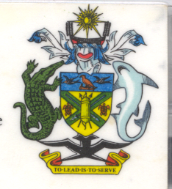
Statement by H.E. Barrett Salato
Ambassador and Permanent Representative Solomon Islands
at Guyana’s Review, 35th Session of the UPR,
Geneva 20-31 January 2020
Check Against Delivery

Thank you, Madame President.

Solomon Islands welcomes to the delegation of Guyana and thanks the delegation for the presentation of its national report. Solomon Islands congratulates Guyana on the many achievements specified therein.

We note Guyana promotion and protection of human rights on the ground: the National Commission on Disability (NCD) which has taken consistent action to ensure the implementation of the Persons with Disabilities Act 2010 to improve their access to education, healthcare, skills development, as well as employment opportunities and protection of their rights.
.

We recognise the work of Guyana to progressively implement human rights including the Juvenile Justice Act 2018 which prohibits all forms of corporal punishment of children eliminates archaic offences such as wandering and truancy and ensures reformation justice for children.

In constructive spirit, Solomon Islands recommends that Guyana:

- Clearly define the mandate and the responsibilities of the national mechanism for the advancement of women and allocating the necessary resources to enable it to promote equality and mainstreaming gender equality and ensuring coordination of activities in this field
- Train competent facilitators or service providers to deliver the Health and Family Life Education program, in line with the UN guidelines on comprehensive sexuality education.
- Addressing the root causes of trafficking and prostitution, including poverty, in order to eliminate the vulnerability of girls and women to sexual exploitation and trafficking, and to make efforts to ensure the recovery and social reintegration of victims

Salomon Islands wishes the delegation of Guyana a successful UPR.
I thank you.

