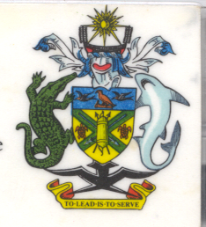
Statement by H.E. Barrett Salato
Ambassador and Permanent Representative Solomon Islands
at Guinea’s Review, 35th Session of the UPR,
Geneva 20-31 January 2020
Check Against Delivery

Thank you, Madame President.

Solomon Islands welcomes to the delegation of Guinea and thanks the delegation for the presentation of its national report. Solomon Islands congratulates Guinea on the many achievements specified therein.

Solomon Islands acknowledges Guinea’s efforts to advance human rights domestically since the last UPR cycle and its efforts to continue and consolidate the process of promoting and protecting human rights that includes laws on sectoral rights, the independence of the judiciary and the prevention and punishment of human rights violations.

In a constructive spirit, Solomon Islands recommends that Guinea:

- Supports the Ministry of Human Rights and Civil Liberties to take the necessary measures to ensure that an independent national human rights institution is in conformity with the Paris Principles and promotes and protects human rights, including freedoms of expression and opinion, as well as social and economic rights.

- Continues to strengthen its national policies to promote equality in the areas of education, health and employment of women and girls.

- Redoubles efforts aimed at reducing the high incidence of female genital mutilation and other practices that are harmful and discriminate against women

Salomon Islands wishes the delegation of Guinea a successful UPR.

I thank you.

