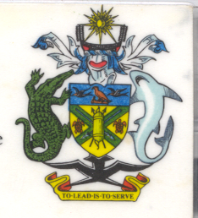
Statement by H.E. Barrett Salato
Ambassador and Permanent Representative Solomon Islands
at Turkey’s Review, 35th Session of the UPR,
Geneva 20-31 January 2020
Check Against Delivery

Thank you, Madame President.

Solomon Islands welcomes to the delegation of Turkey and thanks the delegation for the presentation of its national report.

Solomon Islands acknowledges Turkey’s efforts to advance human rights domestically since the last UPR cycle and its efforts to enhance compliance with the recommendations of international human rights mechanisms both in law and practice.

In a constructive spirit, Solomon Islands recommends that Turkey:
- Withdraw the reservation regarding Article 27 of the ICCPR,
- Urge state media and state leaders at all levels to meet their obligations under the Constitution’s Article 10, treat all people equally regardless of religion, and speak against derogatory statements made towards Jews, Christians, and other religious minorities,
- Return confiscated church properties, allow church properties to be used as determined by the church, and ensure local governments are fairly reviewing requests for uses of property as worship spaces without undue interference from the federal government,
- Fully comply with judicial decisions made at national and international levels that affirm the freedom of religion and associated freedoms and rights,
- Ensure students are not required to reveal their religion in order to be exempted from school religion classes, or make school religion classes voluntary,
- Permit Alevis and all other religious groups the same access to government benefits for religious organizations as Sunni Muslims,
- Revoke the current ban on elections of board members for religious foundations, streamline the registration process for foundations and associations, and eventually recognize religious organizations directly as having legal personality and the ability to own and dispose of property,
- Permit religious organizations to hold elections for their religious leaders without government interference,
- Respect conscientious objectors without discrimination,
- Permit entrance into the country by religious groups, including religious leaders, and refrain from deporting individuals for their religious work,

Salomon Islands wishes the delegation of Turkey a successful UPR.

I thank you.

