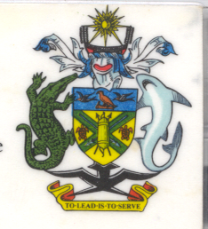
Statement by H.E. Barrett Salato
Ambassador and Permanent Representative Solomon Islands
at Lesotho’s Review, 35th Session of the UPR,
Geneva 20-31 January 2020
Check Against Delivery

Thank you, Madame President.

Solomon Islands welcomes to the delegation of Lesotho and thanks the delegation for the presentation of its national report. Solomon Islands congratulates Lesotho on the many achievements specified therein, as well as on ratifying all the nine core treaties on human rights.

In a constructive spirit, Solomon Islands recommends that Lesotho:

- Affirm that the right to life applies from conception until natural death, and as such that the unborn child has the right to protection of his or her life at all points;
- Resist calls to further liberalize abortion, and instead implement laws aimed at protecting the right to life of the unborn;
- Recognize that the legalization of abortion, in a country with high levels of maternal mortality and morbidity and with severe problems with access to adequate quality health-care, will not make pregnancy and childbirth any safer;
- Take further measures to improve health care infrastructure, access to emergency obstetric care, midwife training, and resources devoted to maternal health;
- Advance efforts to safely get mothers and babies through pregnancy and childbirth, with special attention paid to improving health-care access for women from poor and/or rural backgrounds;
- Continues to prioritize poverty reduction in protection and promotion of economic, social and cultural rights of its people, strengthen the construction of its health system, increase the coverage of service level of the medical care, and put further attention to combating AIDS;
- Develops and adopts social policies and legal measures aimed at enabling all children to benefit from quality education, with adeq uate social assistance to guarantee full access to education to people with disabilities.

Salomon Islands wishes the delegation of Lesotho a successful UPR.

I thank you.

