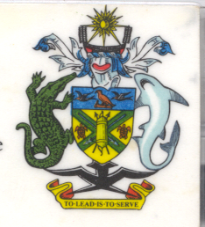
Statement by H.E. Barrett Salato
Ambassador and Permanent Representative Solomon Islands
at Sweden’s Review, 35th Session of the UPR,
Geneva 20-31 January 2020
Check Against Delivery

Thank you, Madame President.
Solomon Islands warmly welcomes the delegation of Sweden and thanks them for the positive engagement during this UPR process.

Solomon Islands acknowledges Sweden’s efforts to advance human rights domestically since the last UPR cycle, including the bill on ILO Convention (No. 189) in 2018 on decent work for domestic workers to guarantee rights such as regulated working hours, employment contracts, access to information and adequate social security.

We note Sweden’s efforts to give effect to the national plan of 2016 that recognises the importance of working on a broad front against racism, hostility and hate crimes.

In constructive spirit, Solomon Islands recommends that Sweden :

- Ensure that the right to freedom of religion is duly recognized and respected;
- Review and amend the requirements set out for parents intending to home-school their children;
- Review the Education Act and amend it in accordance with international law;
- Review the proposed legislative ban on faith-based private schools;
- Respect the right guaranteed under international law of parents to raise and educate their children in accordance with their moral and religious convictions;
- Recognize that the State has no legitimate authority under international law to mandatorily prescribe conventional education for all children, that individuals have the right to seek alternative forms of education, and that the prohibition and criminalisation of home education is a violation of international human rights law;
- Respect the right guaranteed under international law of parents to raise and educate their children in accordance with their moral and religious convictions;
- Recognize that the State has no legitimate authority under international law to mandatorily prescribe conventional education for all children, that individuals have the right to seek alternative forms of education, and that the prohibition and criminalisation of home education is a violation of international human rights law.

Salomon Islands wishes the delegation of Sweden a successful UPR.
I thank you.

