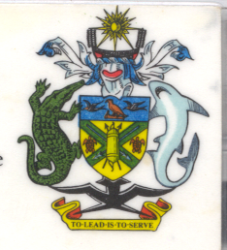
Statement by H.E. Barrett Salato
Ambassador and Permanent Representative Solomon Islands
at Spain’s Review, 35th Session of the UPR,
Geneva 20-31 January 2020
Check Against Delivery

Madame President,
Solomon Islands welcomes the delegation of Spain and thanks them for the positive engagement during this UPR process and thanks it for the comprehensive National Report.

We acknowledge efforts and initiatives of the Government of Spain which has made significant progress in meeting its obligations through incorporating human rights principles into national legislation: the adoption of the first National Covenant on Combating Gender- based Violence 2018–2022, the Plan of Action to Combat Hate Crimes was adopted in 2019 and the Comprehensive Plan to Combat Trafficking in Women and Girls for the Purpose of Sexual Exploitation 2015–2018.
In constructive spirit, Solomon Islands recommends that Spain :
- Ensure the freedom of religion or belief in Spain, both in law and in practice, for adherents of all religions, and root out all cases of religious discrimination in laws against members of religious minorities;
- Fulfil the right to social security of protestant pastors who were discriminated during and after Franco’s regime and who have been excluded from access to the pension system;
- Foster an environment of religious harmony and cooperation, and cease discriminating against individuals or communities on the basis of their religious denominations;
- Repeal the Catalonian legislation on places of worship and bring current legislation in conformity with international human rights instruments pertaining to the protection of the right to freedom of religion or belief, which includes the right to worship in community with other, in public or in private and refrain from any discriminatory provisions targeting religious minorities;
- Affirm the prior right of parents to choose the kind of education that shall be given to their children in accordance with Article 26 of the UDHR;
- Recognize that the State has no legitimate authority under international law to mandatorily prescribe conventional education for all children, that individuals have the right to seek alternative forms of education.
Salomon Islands wishes the delegation of Spain a successful UPR.

I thank you.

