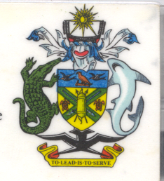
Statement by H.E. Barrett Salato
Ambassador and Permanent Representative Solomon Islands
at Kiribati’s Review, 35th Session of the UPR,
Geneva 20-31 January 2020
Check Against Delivery

Madam President,

Solomon Islands welcomes the delegation of Kiribati and thanks them for the positive engagement during this UPR process, the respect for human rights and the broad commitment to cooperating with the Human Rights Council and all other international mechanisms.

We recognise the work of Kiribati to progressively implement human rights including the ratification of the Convention against Torture and Other Cruel Inhuman or Degrading Treatment or Punishment in 2019. We acknowledge efforts and initiatives of the Government of Kiribati, which has made significant progress in meeting its obligations through incorporating human rights principles into national legislation.

We also recognise the country's plans as it relates to human rights around equality and elimination of sexual and gender-based violence, right of persons with disabilities, child’s rights, as well as Implementation Plan specifically on Climate Change and Disaster Risk Management.

In constructive spirit, Solomon Islands recommends that Kiribati :

- Ratify the International Covenant on Economic, Social and Cultural Rights as well as the International Covenant on Civil and Political Rights;

- Establish a national institution for human rights in accordance with the Paris Principles, seeking international technical cooperation if necessary;

- Strengthen its legal and institutional frameworks with respect to the implementation of human rights and the right to water and sanitation.

Salomon Islands wishes the delegation of Kiribati a successful UPR.

I thank you.

