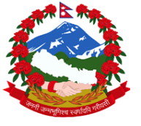
Statement by the delegation of Nepal
UPR of Spain
35th session of the Working Group on the Universal Periodic Review
22 January 2020

Time 1 min

Madam President,

Nepal warmly welcomes the delegation of Spain to the third cycle of UPR.

Nepal commends the active participation and important contribution made by Spain for the cause of protection and promotion of human rights.

It is encouraging to note Spain’s achievement towards gender parity, which is reflected now in senior government positions.

Also impressive is the advancement in concepts such as ‘human right to sharing benefits of scientific advancement’.

While wishing Spain a successful review, we recommend the following:

- Continue measures to combat trafficking in persons while safeguarding victims’ right to justice.

- Enhance support services to migrants, in view of particular needs for the protection and promotion of rights of migrant children.

I thank you.

