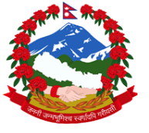
Statement by the delegation of Nepal
UPR of Kuwait
35th session of the Working Group on the Universal Periodic Review
29 January 2020

Check against delivery
Time: 55 sec (Words: 129)
Madam President,

Nepal warmly welcomes the delegation of Kuwait to the third cycle of UPR.

We appreciate Kuwait’s active engagement with the UN human rights mechanisms.

Nepal welcomes the adoption of Kuwait Vision 2035.

We commend the progress achieved in Kuwait, including on ensuring access to quality health care.

Kuwait’s commitment to humanitarian efforts is praiseworthy.

We also take positive note of the adoption of legislative measures for safeguarding the interest of domestic workers.

While wishing Kuwait a successful review, we recommend:

- Continue to implement legislative measures for promotion of gender equality and non-discrimination.

- Continue efforts to protect the rights and welfare of migrant workers, including women domestic workers, by ensuring access to remedies and complaint mechanisms.

I thank you.

