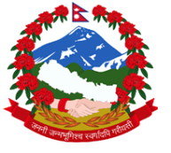
Statement by the delegation of Nepal
UPR of Armenia
35th session of the Working Group on the Universal Periodic Review
23 January 2020

Time: 1 min 10 sec

Madam President,

Nepal warmly welcomes the delegation of Armenia to the third cycle of UPR.

We commend Armenia’s active engagement with human rights mechanisms.

We note the signing of the Second Optional Protocol to the ICCPR towards abolition of the death penalty.

We welcome Armenia’s approach to advance international cooperation in the implementation of the Sustainable Development Goals.

We believe that innovative platform of Armenia National SDG Innovation Lab would contribute to strengthen partnerships for the acceleration of SDG implementation.

While wishing Armenia a successful review, we recommend the following:

- Continue to take measures of affirmative actions for political representation of minorities.

- Continue enforcing legislation to combat domestic violence and extend rehabilitation services for the victims.

I thank you.

