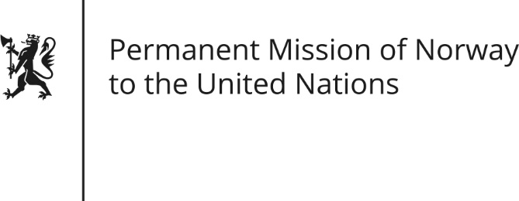

STATEMENT by Senior Adviser Carina Ekornes

35th Session of the Universal Periodic Review

Kuwait

29 January 2020

Check against delivery
President,
Norway welcomes Kuwait’s participation in the UPR and notes the positive steps taken since its last review [,including important legal reforms protecting guest workers].
Norway remains, however, concerned about the implementation of new legislation related to worker’s rights [and other vulnerable groups].
Norway recommends:
- Continue to improve the rights of domestic workers, including mechanisms for
complaints and sanctions for law violations.
2) Provide full citizenship and rights for the Bidoun population.
3) Take concrete steps towards the abolition of the death penalty.
4) Ensure freedom of expression in all forms and take concrete steps to ensure the independence of the media, prevent censorship and promote transparency in public affairs.
5) [Take legislative and other measures to] continue strengthening protective
measures and legal rights for women.
Thank you.

