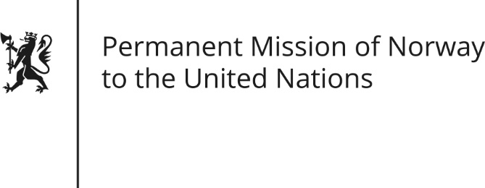

STATEMENT by Senior Adviser Kristian Borgen

35th Session of the Universal Periodic Review

Armenia

23 January 2020

Check against delivery

President,
Norway welcomes the renewed commitment to reform in Armenia following the “Velvet Revolution”. [Reports that civil society is significantly more included in policy making than before are encouraging.]
We remain concerned about the situation of human rights defenders, violence against women and discrimination against vulnerable groups.
Norway recommends:
1) Carry out prompt, independent and just investigations into attacks on human rights defenders in order to ensure that those responsible are brought to justice[, as well as taking necessary steps to prevent them from happening].
2) Combat hate speech and hate crimes, which includes adequate references to skin colour, ethnicity, religion, belief, sexual orientation or disability by adopting necessary adjustments to legislation.
3) Ratify the Istanbul Convention [and adjust national legislation accordingly].
4) Adopt measures to tackle discrimination against HIV-positive individuals in the healthcare system[, and take steps to make treatment more accessible in the regions].
Thank you.

