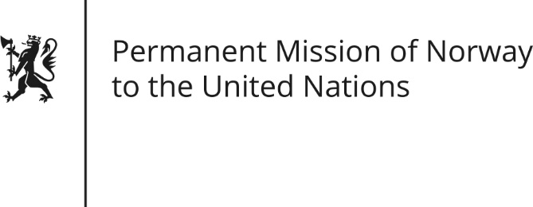

STATEMENT by Minister Counsellor Anniken Enersen

35th Session of the Universal Periodic Review

Lao People`s Democratic Republic

21 January 2020

Check against delivery

President,
Norway welcomes The Lao PDR’s participation in the UPR [and notes the positive step to invite the UN Special Rapporteur on Extreme Poverty and Human Rights to visit the country in 2019.]
Norway remains concerned about the reports of unresolved disappearances of [several] Lao human rights defenders, and the arrests of people who express their views peacefully.
Norway recommends:
- Create and maintain a safe and enabling environment for human rights defenders [and civil society to constructively contribute to policy-making and national development].
- Ensure that all women and girls have access to appropriate sexual and reproductive health services, [and implement policies, including awareness raising, to prevent and respond to violence against women and girls.]
- Ensure that freedom of expression is safeguarded in all its forms.
- Continue to take concrete action to address disparities in access to education, especially among rural ethnic groups, [as a means to combat poverty, early marriage and human trafficking.]
- Develop a national action plan for full implementation of the UN Guiding Principles on Business and Human Rights.
Thank you.

