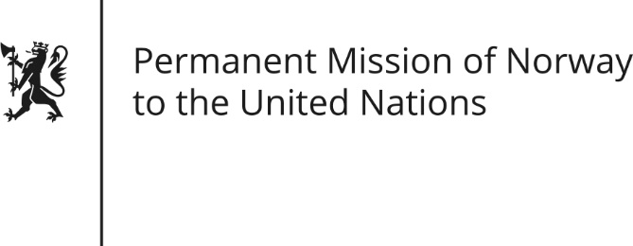

STATEMENT by Foreign Service Trainee Helene Opsal

35th Session of the Universal Periodic Review

Turkey

28 January 2020

Check against delivery
President,
Norway welcomes Turkey’s participation in the UPR and notes that the Human Rights situation has deteriorated since its last review, despite some positive steps taken [including the launching of Turkey’s judicial reform package].
Norway recommends:
1. Ensure freedom of expression in all its forms by refraining from censoring social and conventional media [including online], and fully enabling and respecting academic and artistic freedom.
2. Continue to strengthen and ensure women’s rights, by combatting violence against women and fully implementing the Istanbul Convention.
3. Strengthen the independence of the judicial system and follow due judicial process according to Turkey’s international obligations and standards.
4. Ensure and practice non-discrimination on the basis of sexual orientation and gender identity.
5. Fully respect the right to assembly and create a safe and enabling environment for human rights defenders.
Thank you.

