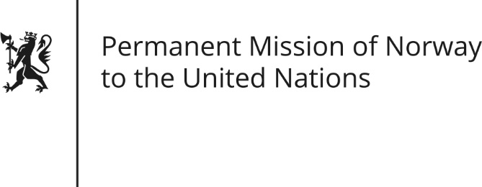

STATEMENT by Minister Counsellor Anniken Enersen

35th Session of the Universal Periodic Review

Sweden

27 January 2020

Check against delivery

President,
Norway welcomes Sweden’s participation in the UPR and notes the positive steps taken since its last review to ensure that Sámi people can exercise their rights, including Sweden’s efforts in negotiating the Nordic Sámi Convention.
Norway recognises that the power to ratify ILO Convention No. 169 is vested in the Parliament, Riksdagen.
Norway therefore recommends that the Swedish Government
1) Continues to work towards ratification of ILO Convention No. 169 while considering further measures to strengthen the Sámi People’s access to influence, participation and livelihoods.
Thank you.

