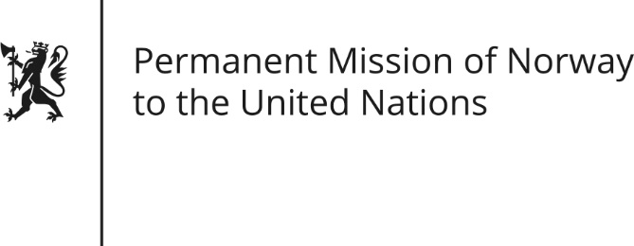

STATEMENT by First Secretary Sean Lobo

35th Session of the Universal Periodic Review

Kenya

23 January 2020

Check against delivery
President,
Norway welcomes Kenya’s participation in the UPR and notes the positive steps taken since its last review[, including Kenya’s commitment in 2015 to develop a National Action Plan for the implementation of the Guiding Principles on Business and Human Rights.]
[Norway remains concerned about the lack of implementation of the Public Benefit Organizations Act.]
Norway recommends:
1) Ensure a safe and enabling environment for human rights defenders including by investigating attacks.
2) Implement the Public Benefit Organizations Act swiftly.
3) Ensure the final approval, launch and execution of the National Action Plan for the implementation of the Guiding Principles on Business and Human Rights.
4) Finalize, adopt and implement the Draft National Action Plan to Ending Child Marriage.
5) Adopt a comprehensive equality and non-discrimination law that affords protection to all individuals regardless of their sexual orientation, gender identity or expression.
6) Strengthen gender equality by implementing the two-thirds gender principle in all elective or appointive bodies in a timely manner.
Thank you.

