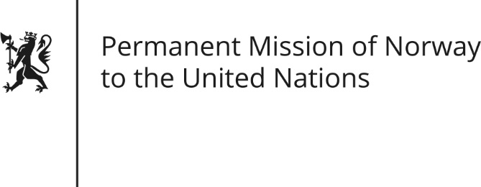

STATEMENT by First Secretary Alf Håvard Vestrheim

35th Session of the Universal Periodic Review

Spain

22 January 2020

Check against delivery
President,
Norway welcomes Spain’s participation in the UPR and notes the positive steps taken since its last review.
We note however that further progress is possible in some areas.
Accordingly, Norway would like to take this opportunity to recommend that the Spanish Government ensure real and effective equality in women's economic and corporate life, including by enacting legislation on gender equality that ensures transparency in corporations and public administration.

Thank you.

