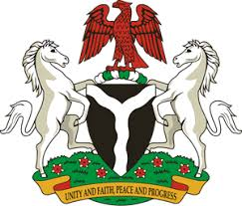
Please check against delivery
HUMAN RIGHTS COUNCIL
35TH SESSION OF THE WORKING GROUP OF THE UPR
REVIEW OF KYRGYZSTAN
20TH JANUARY, 2020
STATEMENT BY NIGERIA
Madam President,
Nigeria welcomes the delegation of the Kyrgyz Republic to the country’s Third Cycle UPR, and thanks it for the update provided today, highlighting the country’s efforts in the promotion and protection of human rights. We commend the Government of Kyrgyzstan for its efforts in implementing the previous recommendations and its commitment to the UPR process.
2. Nigeria notes with encouragement, efforts by the Government of Kyrgyzstan in strengthening the country’s legal and institutional frameworks for the promotion and protection of human rights. We also take positive note of the Government’s efforts in developing the juvenile justice system in the country.
3. In the spirit of constructive dialogue, Nigeria recommends the following to Kyrgyzstan:
- Adopt further measures to protect the rights of vulnerable groups, especially women and children, as well as persons with disabilities; and
- Scale up efforts in the promotion and protection of human rights of its population.
4. In conclusion, we wish Kyrgyzstan every success in its review process.
I thank you, Madam President.
******

