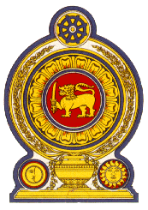
Statement by Sri Lanka
35th Session of the UPR
Review of Kenya – 23 January 2020

Mr. President,

Sri Lanka warmly welcomes the delegation of Kenya and appreciates its presentation of a comprehensive national report as well as its engagement with the HRC today.

We commend Kenya putting in place the National Plan of Action for Children (2015 – 2022) and Kenya’s Mental Health Policy (2015 – 2030)

We also note the mandating of free secondary education for all Kenyans.

While acknowledging the important measures taken by Kenya on migrant workers and that migrant workers in Kenya are recognized under the Employment 2007, which promotes and guarantees equal opportunities for migrant workers or a member of the family of the worker,

We take this opportunity to recommend that Kenya :

- Ratifies the International Convention on the Protection of the Rights of Migrant Workers and Members of Their Families

- Strengthens efforts to ensure that all Kenyans enjoy access to education without discrimination

- Ratifies the Optional Protocol to the Convention on the Rights of Persons with Disabilities

Finally we wish Kenya success in its UPR engagement.

Thank you.

