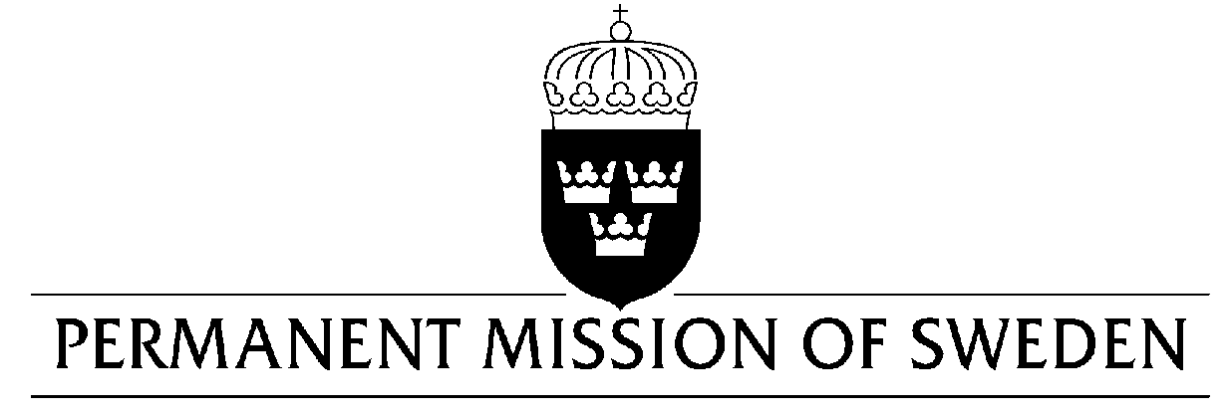
UN Human Rights Council

UPR 35th session

Statement by Sweden in the interactive dialogue on Turkey

Delivered by ms Clara Molin, Second secretary
Geneva, 28 January 2020 (speaking time 0.50 min, speaker no.119)

Madame President,

Sweden would like to make the following recommendations:

- To reform the penal code, including the law on counter-terrorism, to ensure respect for freedoms of opinion and expression, online as well as offline, in full accordance with Turkey’s international obligations.

- To release all those democratically elected politicians that have been arbitrarily detained or arrested and refrain from further violations in this regard.

- To adopt a comprehensive anti-discrimination legislation which includes sexual orientation and gender identity as protection grounds.

Sweden notes with concern the negative developments with regard to the implementation of human rights obligations since the coup attempt in 2016. The legislation introduced in the aftermath of the state of emergency in 2018 has far-reaching effects on society and institutions including compromising judicial independence and rule of law.

Sweden wishes Turkey all success in the current review.

I thank you Madame President.

