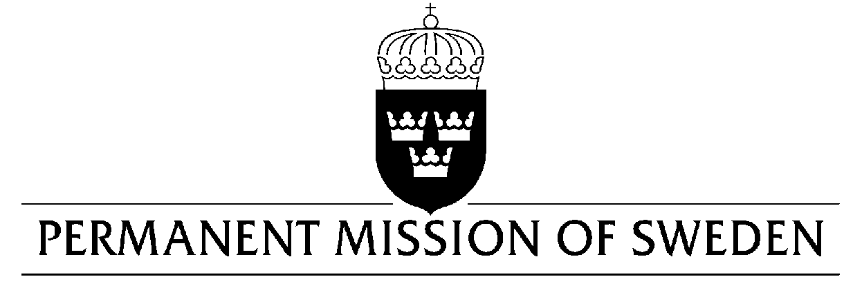
UN Human Rights Council

UPR 35th session

Statement by Sweden in the interactive dialogue on Kenya

Delivered by Permanent Representative Ambassador Veronika Bard
Geneva, 23 January 2020 (speaking time 0.55 min, speaker no.86)

Madame President,

Sweden welcomes ongoing reforms aiming at improved accountability and respect for human rights. However, there is still need for legal reforms and actions to ensure the full enjoyment of human rights for women, girls and LGTBI-persons.
Sweden wish to make the following recommendations:

- To enact legislation implementing the “two thirds gender principle”, as guaranteed in the constitution.

- To adopt and implement a national policy on eradication of Female Genital Mutilation.

- To take concrete measures to adopt a comprehensive anti-discrimination law affording protection to all individuals, irrespective of their sexual orientation or gender identity in conformity with international standards and as accepted during the previous UPR cycle.

Sweden wishes Kenya all success in the current review.

I thank you Madame President.

