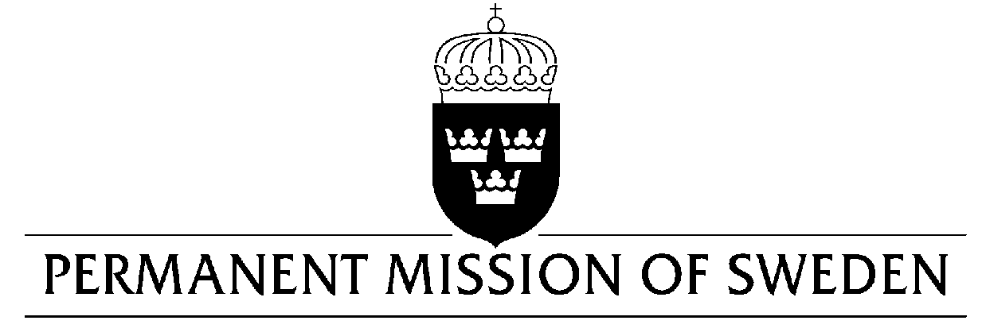
UN Human Rights Council

UPR 35th session

Statement by Sweden in the interactive dialogue on Armenia

Delivered by Ms Clara Molin, Second secretary
Geneva, 23 January 2020 (speaking time 1.10 min, speaker no.73)

Madame President,

Sweden welcomes the developments in Armenia since the “Velvet Revolution” of 2018 and acknowledges the commitment of the Government of Armenia to strengthen the respect for human rights, democracy, and the rule of law- including justice sector reform. However, there has been a worrying backlash in the form of disinformation, increased harassments and incitement to hatred against human rights defenders and civil society, notably women and LGBTI-persons, and there is still no anti-discrimination legislation in place.

Sweden would like to make the following recommendations:

- To effectively implement judicial reform, in close cooperation with the Council of Europe, to ensure an impartial and transparent judicial system.

- To ratify the Council of Europe Convention on preventing and combating violence against women and domestic violence (Istanbul Convention)

- To adopt a law on anti-discrimination which includes sexual orientation and gender identity as protection grounds.

- To take measures to protect human rights defenders and civil society from harassment.

Sweden wishes Armenia all success in the current review.

I thank you Madame President.

