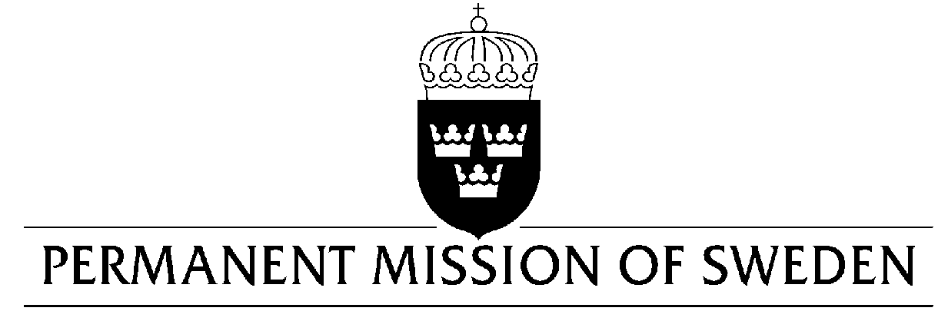
UN Human Rights Council

UPR 35th session

Statement by Sweden in the interactive dialogue on Spain

Delivered by Permanent Representative Ambassador Veronika Bard
Geneva, 22 January 2020 (speaking time 1 min, speaker no.53)

Madame President,

Sweden welcomes the improvements relating to gender equality and the human rights of migrant since the last UPR cycle. However, we would like to encourage further efforts to improve the prevention and combatting of human trafficking, including the protection of persons in vulnerable situations, as well as to ensure the right to seek asylum for all migrants under Spanish jurisdiction. Sweden would like to make the following recommendations:

- To take measures to prevent and combat human trafficking and sexual exploitation, including by reducing demand and ensuring legislation that enables a systematic prosecution of these offences.

- To ensure that asylum and migration policies fully respect international law, including the right to seek asylum.

- To adopt measures to ensure thorough and efficient implementation of international and regional obligations on gender equality in national legislation.

Sweden wishes Spain all success in the current review.

I thank you Madame President.

